Final List: 5 Influencers for Amul Probiotic Yogurt
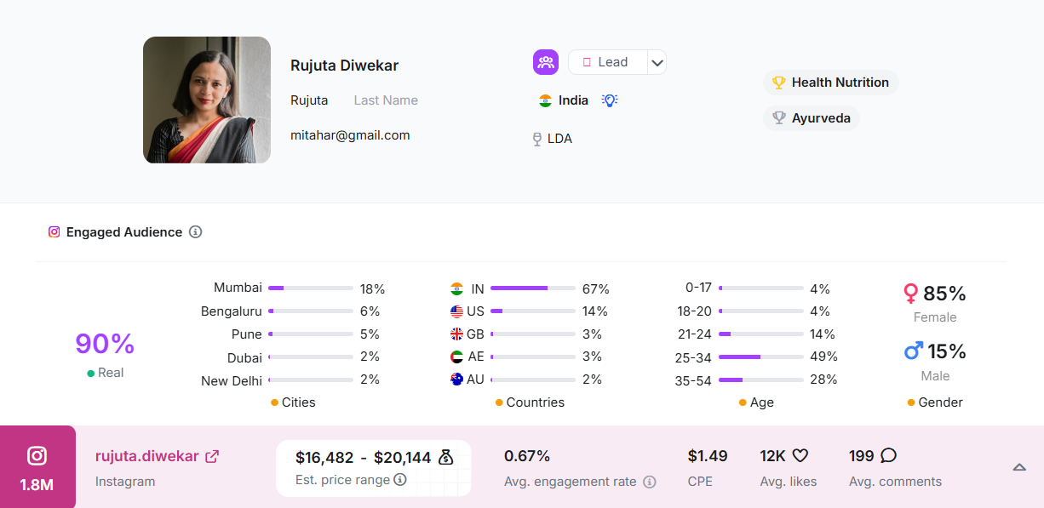
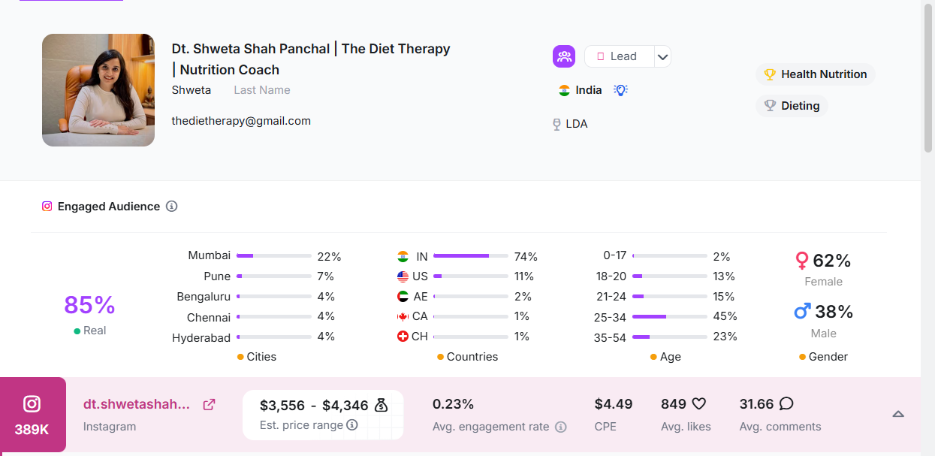
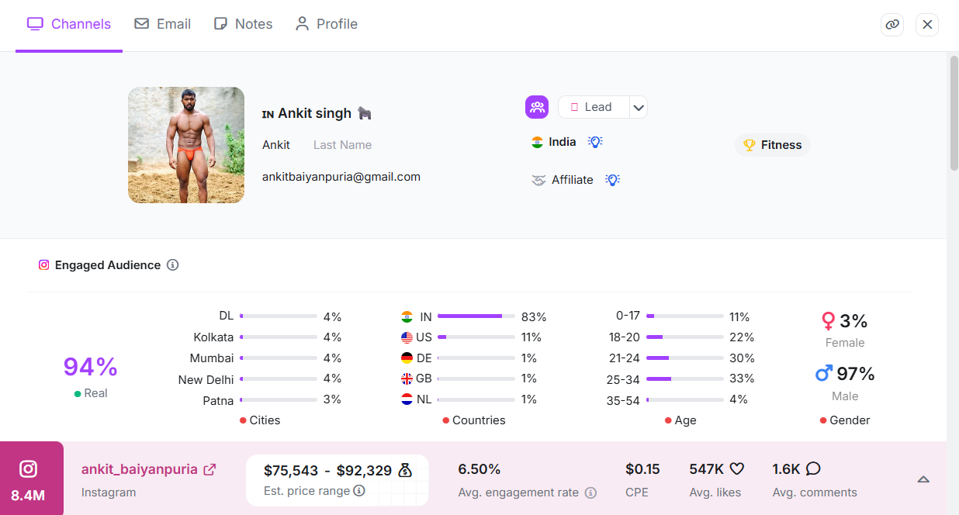
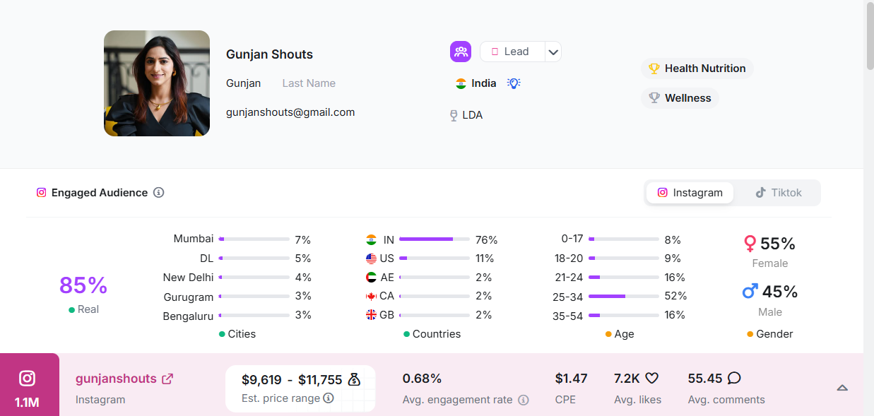
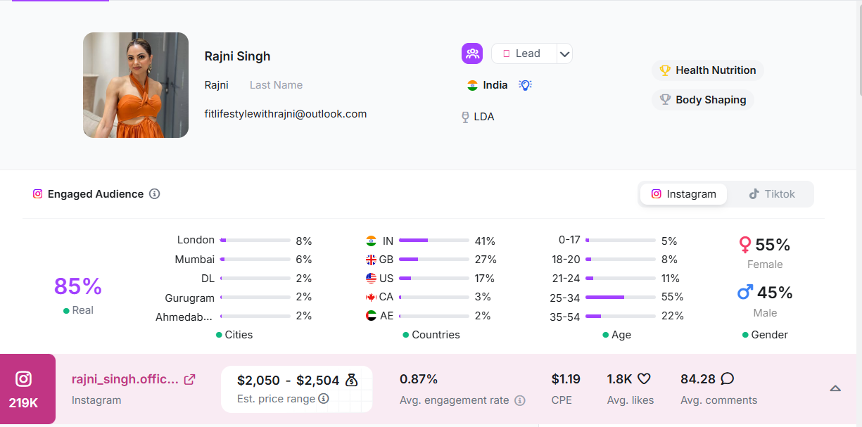
Influencer Classification Table
Influencer Name | Platform | Followers | Niche | Category
Rujuta Diwekar | Instagram | 1.8M | Nutrition & Gut Health | Mega
 |  |  | Nutrition & Gut Health
  Health with Shweta
  Instagram
  35K
  Micro
  Ankit Baiyanpuria
  Instagram
  6.5M
  Fitness
  Mega
Nutrition by Gunjan | Instagram | 95K | Nutrition | Micro
Rajni Singh | Instagram | 219k | Health, Nutrition, Body Shaping | Macro

Justify Selection
[1] Rujuta Diwekar
Rujuta Diwekar is a well-known Indian nutrition expert who strongly promotes gut health and traditional eating habits. Her audience trusts her food and health advice. Amul Probiotic Yogurt fits naturally into her messaging around digestion and daily wellness. Her large reach helps build strong brand awareness at a national level.
[2] Health with Shweta shah
Health with Shweta focuses on nutrition and gut health for everyday Indian lifestyles. Her followers are health-conscious adults looking for simple diet improvements. As a micro influencer, she has high engagement and trust. Amul Probiotic Yogurt aligns well with her educational content on digestion and healthy eating.
[3] Ankit Baiyanpuria
Ankit Baiyanpuria promotes fitness, discipline, and healthy living using Indian methods. His audience consists of young fitness enthusiasts who value strength and daily health routines. Amul Probiotic Yogurt can be positioned as a natural, digestion-support food that complements an active lifestyle. His massive reach helps drive high visibility for the campaign.
[4] Nutrition by Gunjan
Nutrition by Gunjan shares practical nutrition advice focused on balanced diets and gut health. Her audience includes working professionals and health-aware individuals. Probiotic yogurt fits well with her content around improving digestion and immunity. As a micro influencer, she offers credibility and strong audience connection.
[5] Rajni Singh
Rajni Singh creates content around health, nutrition, and body shaping. Her audience is interested in fitness, weight management, and healthy food choices. Amul Probiotic Yogurt can be promoted as a smart daily food for digestion and overall wellness. As a macro influencer, she provides both reach and targeted relevance.
Draft Outreach Message:
